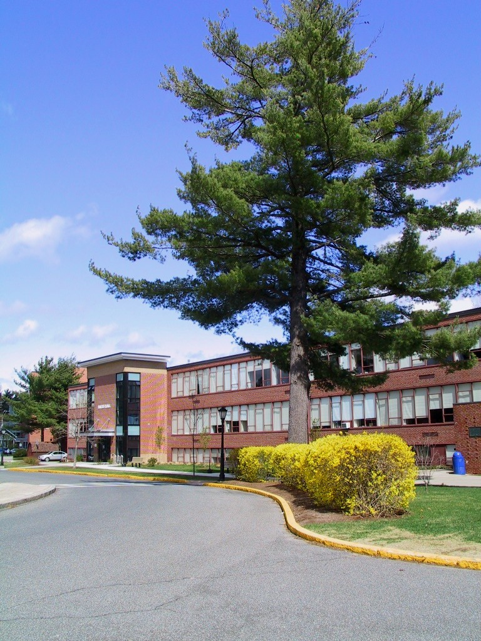

Bates Hall Building Biography

A. Structural Facts

Construction Type 2C
Occupancy Group: A-3 – Music Room; A-4 - Classrooms
Year Built: 1961
Height: 36 ft (including basement)
Area: 49,474 s.f. Tabular: 16,254
Foundation Type Concrete spread footings
Floor / Ceiling: Concrete slab/ VCT and Carpet

Roof: Concrete waffle Built up T&G
Exterior Walls Masonry – Concrete Block, brick veneer
Interior Finish Painted concrete block; hallways and bathrooms ceramic tile
Fuels None in building (Heat and hot water supplied by Power Plant)
Natural Gas – see generator
Heat Supplied by Power Plant (#4 Oil, PH Steam)
Hot Water Supplied by means of instantaneous HPS tankless system located in
Parenzo/Scanlon Utility Tunnel
Ventilation Classroom: Univents, Bathrooms; Roof top exhaust hoods. Basement
partially serviced by central air conditioning. Remainder services by
windows.
Electrical Service 4160 vac 3 phase supplied from Power Plant reduced to 208 vac.
Emergency Light Hallway and corridor lights supplied from emergency generator

Emergency Power 1 generator: 100kw @ 120/208vac, diesel. Supplied emergency
lights fire alarm
Fire Alarm Equip Simplex 2001; hallway pull stations at exits only
Suppression Standpipes at hallway extinguisher cabinets (Insp. By WSC empl)
Smoke Evacuation None
Extinguishers 2 H2O; 3 ABC; 1 BC. Inspected and tested annually by Atwood
Fire Equipment Co.
Chimneys 1 incinerator and ceramic spark arrestor flue (inactive)
Elevator 1 installed 2007
Shafts/Atria Utility pipe chases .
Emergency evacuation signs:
Septic Municipal
Water Municipal
Certificate

B. Building Upgrades

2007
1. New Elevator installed
2. New glass entry area
3. New student lounge over entry ( floor 1 ½)

2008
New Carpet in rooms: 24, 07, 103, 114, 127

